**Project Design Phase-II**

**Data Flow Diagram & User Stories**

|  |  |
| --- | --- |
| Date | 20 October 2022 |
| Team ID | PNT2022TMID03498 |
| Project Name | Classification of Arrhythmia by Using Deep Learning with 2-D ECG Spectral Image Representation |
| Maximum Marks | 4 Marks |

**Data Flow Diagrams:**

A Data Flow Diagram (DFD) is a traditional visual representation of the information flows within a system. A neat and clear DFD can depict the right amount of the system requirement graphically. It shows how data enters and leaves the system, what changes the information, and where data is stored.

Example: DFD Level 0 (Industry Standard)

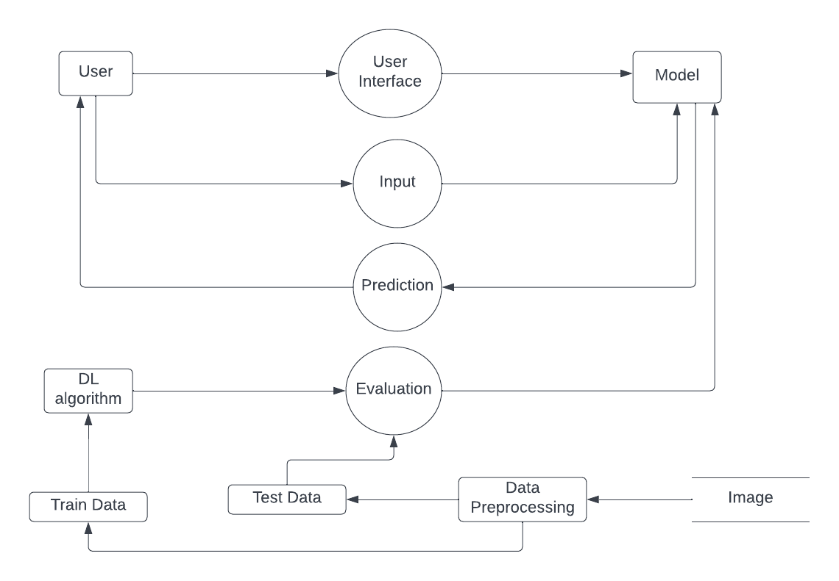**](https://developer.ibm.com/patterns/visualize-unstructured-text/)Example:** [**(Simplified)**](https://developer.ibm.com/patterns/visualize-unstructured-text/)

**User Stories**

Use the below template to list all the user stories for the product.

| **User Type** | **Functional Requirement (Epic)** | **User Story Number** | **User Story / Task** | **Acceptance criteria** | **Priority** | **Release** |
| --- | --- | --- | --- | --- | --- | --- |
| Customer (Mobile user) | Registration | USN-1 | As a user, I can register for the application by entering my email, password, and confirming my password. | I can access my account / dashboard | High | Sprint-1 |
|  |  | USN-2 | As a user, I can register for the application through Gmail |  | Medium | Sprint-1 |
|  | Login | USN-3 | As a user, I can log into the application by entering email & password |  | High | Sprint-1 |
|  | Uploading Pictures | USN-4 | As a user, I can upload the ECG pictures or capture the picture | I can see the result | High | Sprint-2 |
| Customer (Web user) | Registration | USN-5 | As a user, I can register for the application by entering my email, password, and confirming my password. | I can access my account / dashboard | High | Sprint-1 |
|  |  | USN-6 | As a user, I can register for the application through Gmail |  | Medium | Sprint-1 |
|  | Login | USN-7 | As a user, I can log into the application by entering email & password |  | High | Sprint-1 |
|  | Uploading Pictures | USN-8 | As a user, I can upload the ECG pictures or capture the picture | I can see the result | High | Sprint-2 |
| Administrator | Login | USN-9 | As an admin, I can login with some given credentials for limited access of customer details | I can access the admin account | Medium | Sprint-1 |